CS 255 Project 2 System Design Document
Richard Clark
Richard.clark5@snhu.edu

Southern New Hampshire University

CS 255 System Design Document

UML Diagrams

UML Use Case Diagram
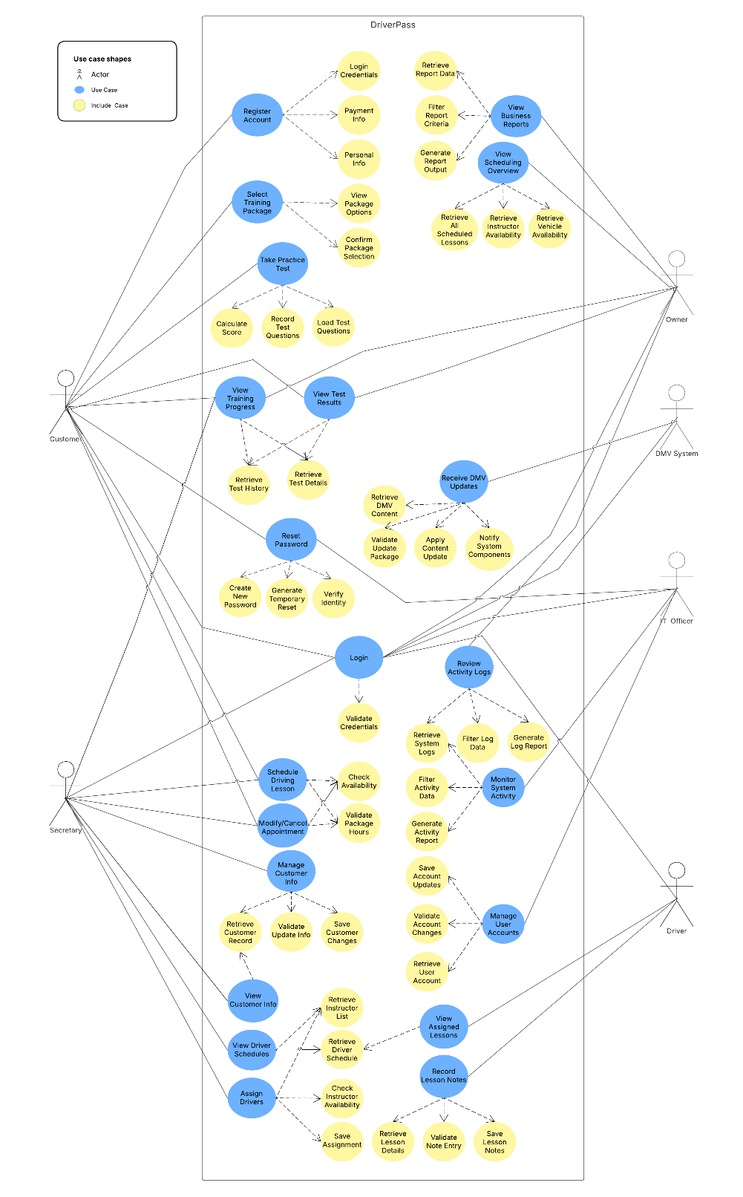

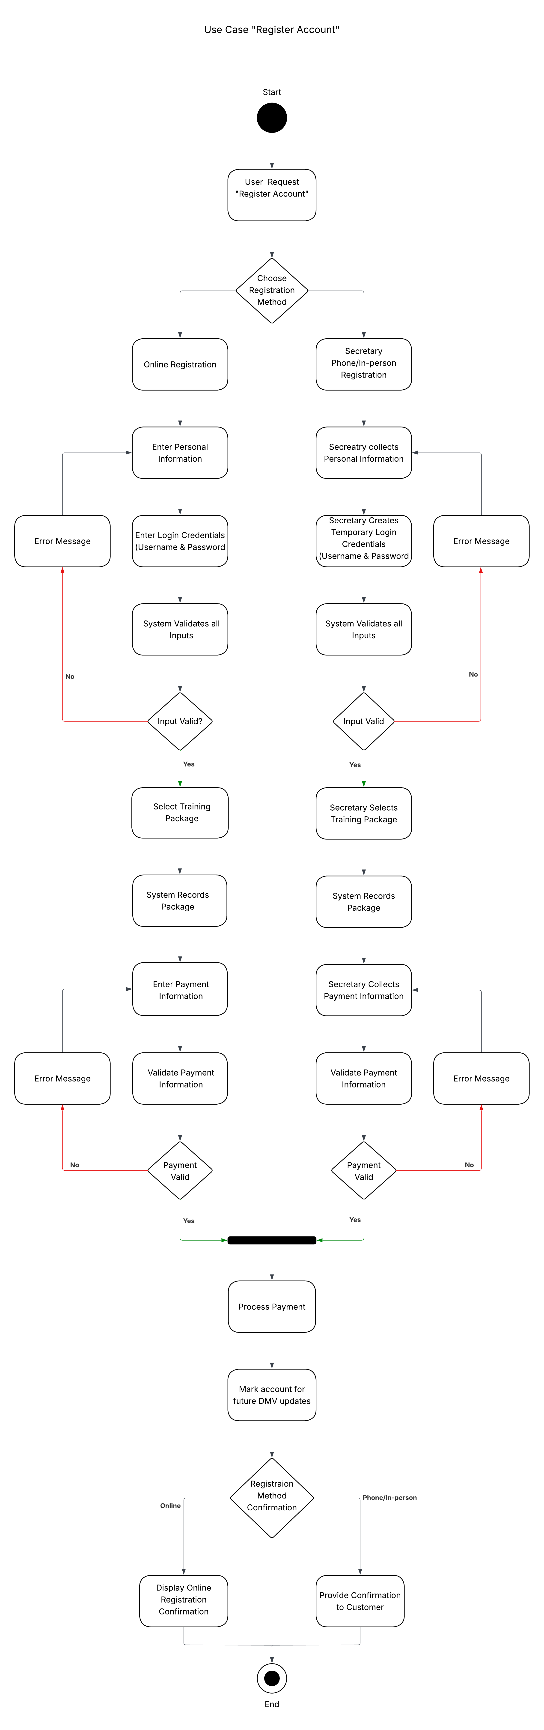
UML Activity Diagrams

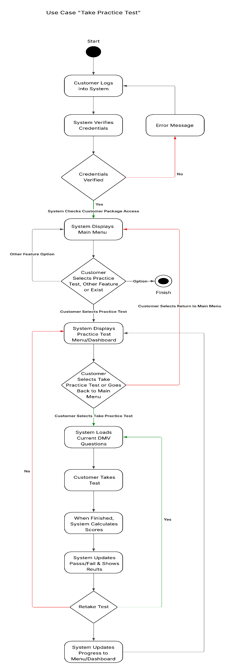
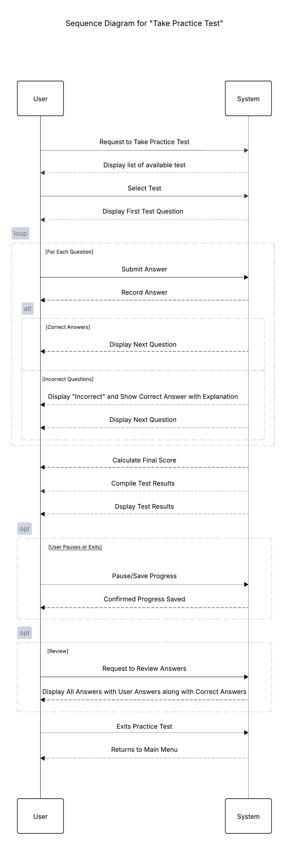

UML Sequence Diagram

UML Class Diagram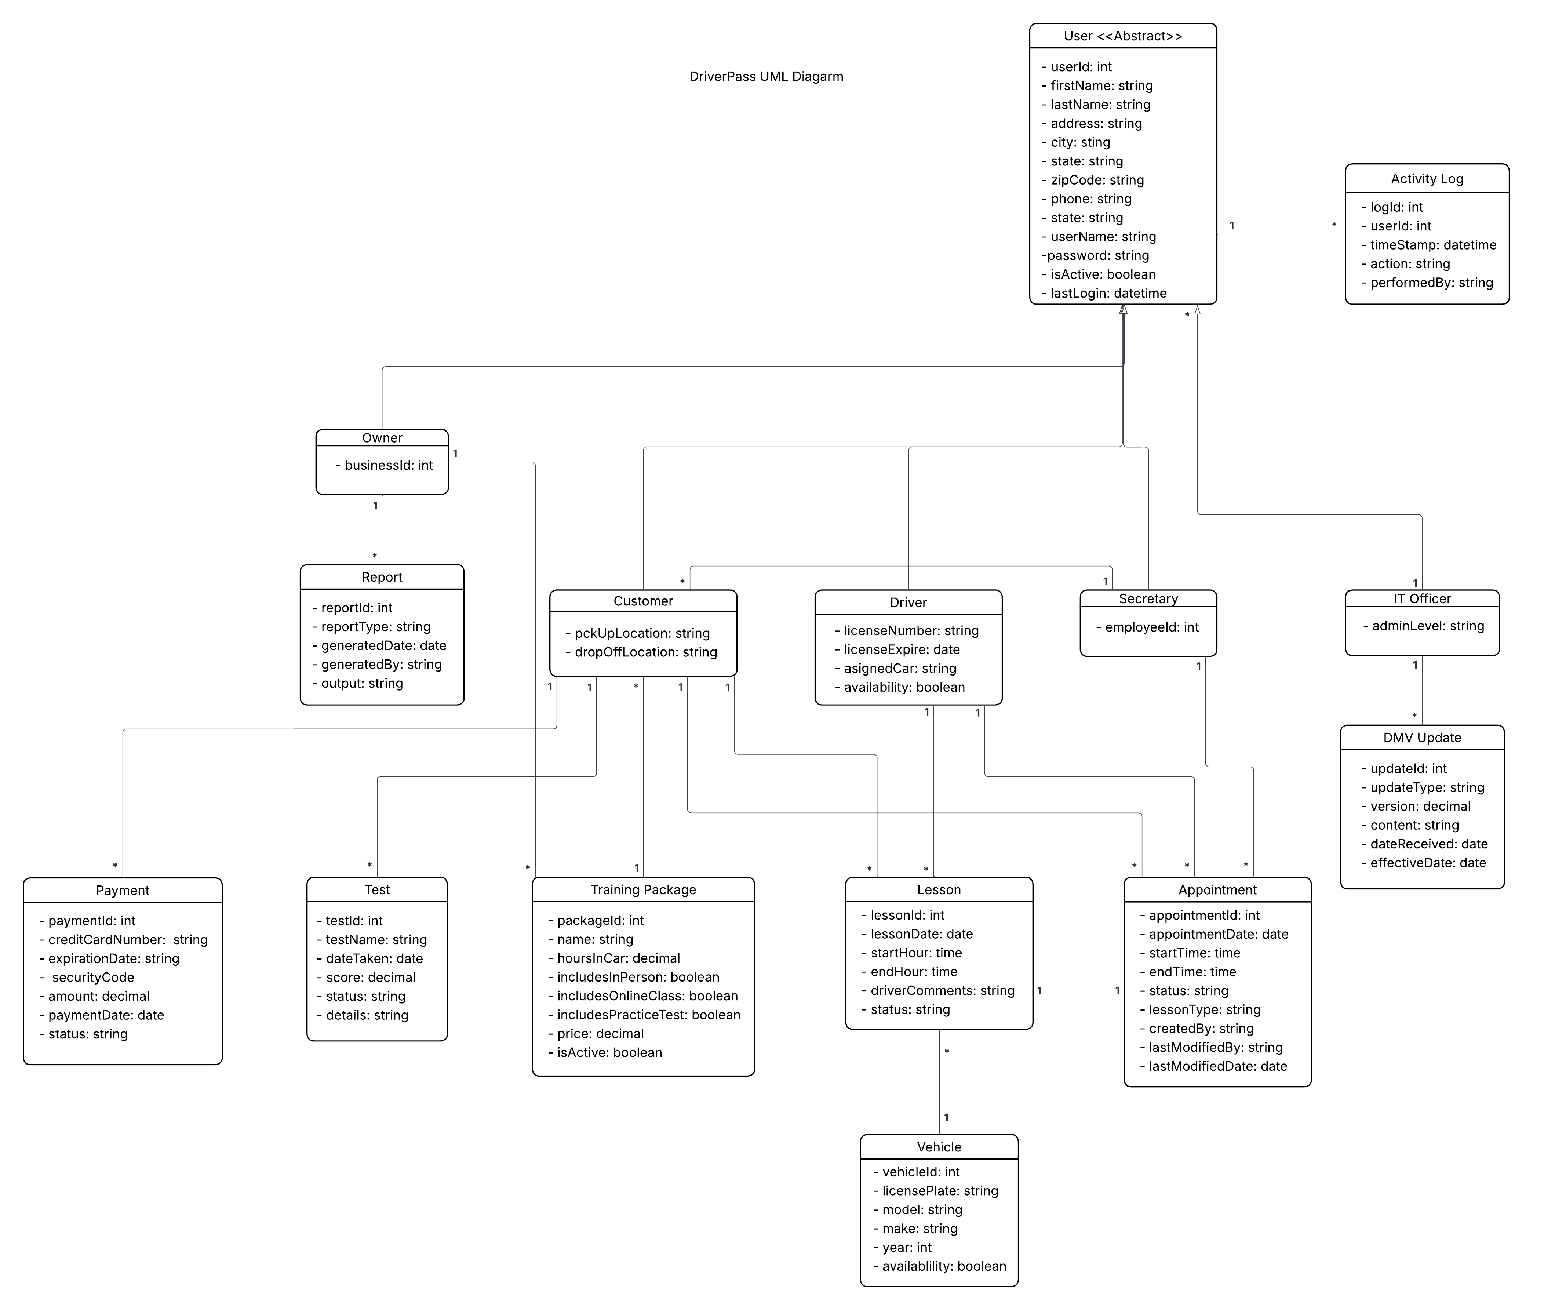

Technical Requirements

The DriverPass system needs basic technology to run a website that many different users can access. It requires a dependable server to host the site and store information, while users only need a computer, tablet, or phone with internet access and a web browser. The system relies on common software tools to handle its core functions, manage data, and display pages. Developers use standard tools to write code, test features, and update the system over time. Security is also important, so the system must protect user information, control access based on roles, and keep records of important actions. The system can run on a company’s own equipment or in the cloud, as long as it includes backups, strong network protection, and the ability to grow as more people use it. It also needs reporting and monitoring features to support scheduling, lessons, testing, payments, DMV updates, and account management.
The software foundation includes a server operating system such as Windows Server or Linux, along with support for users on Windows, macOS, ChromeOS, iOS, or Android. The backend uses a general web framework to run the system’s logic and communicate with the database, while the database stores and organizes all system information. These components work together to keep the application running smoothly.
Developers rely on common tools to build and maintain the system. Programs like Visual Studio or VS Code help write and manage code, Git tracks changes, and tools like Postman or Insomnia help test APIs. Diagramming tools such as Lucidchart, draw.io, or StarUML support system modeling. Testing tools ensure quality, with unit-testing frameworks checking individual parts and UI-testing tools like Selenium or Cypress verifying that the interface works correctly.
The system also needs a stable place to run, either on a physical server or through cloud services like Azure, AWS, or Google Cloud. It requires basic network protection, including a secure firewall, and may use a load balancer if traffic increases. A VPN allows administrators to access the system safely. The database needs automatic backups, recovery options, and controlled access. Because the system will handle many users and large amounts of data, it must be able to scale by adding more servers, increasing database capacity, and using caching to keep performance smooth.

